Assignment 4 Secure Software By Kevin Harianto

portswigger labs:

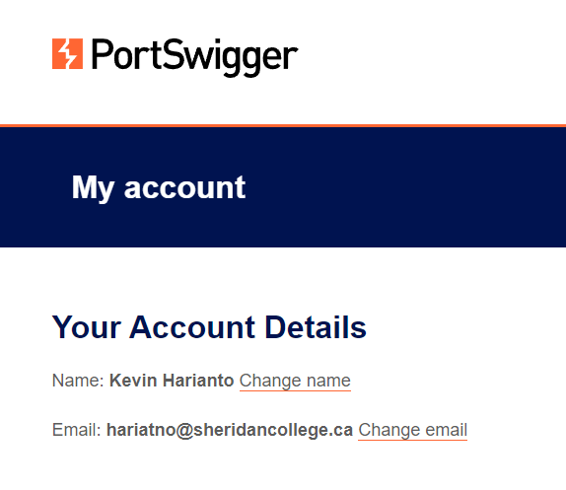

^Created an account

Entered Random

Alphanumerical Characters in search bar

^inspected the page

Noticed that it is also in the img src attribute

Searching for the characters entered.

^In the Inspection area Searched for the random characters entered.

NOTE: Now we will be breaking out of the img src with the help of double qoutes.

Noticed that the img src can be avoided with double quotes at the beginning right after the random characters are entered.

^Solved first lab

Throwing an error to execute the alert

^Second Lab solved

Lab 3:

Going to the submit feedback page



^Changing the return path to random strings

^Inspecting source

Noticed that the website has made a reference on the random string.



^Changing the returnPath to showcase the cookie document.

Pressing the back button to execute the return path

^Lab 3 Is Solved.

Lab 4:

^inside lab 4.

Going to the exploit server

^Inside the exploit server.

^Inserting the malicious iframe provided.

Storing the exploit

Viewing the exploit

^output of the stored exploit.

^Solved Lab 4 by successfully delivering the exploit by the button previously shown.

Lab 5:

^In this case I am executing an SQL Injection lab as previously explained in the assignment description is that I can do any lab provided from the link. I am assuming that SQL injection labs are good.

^In the login account to bypass.

SQL Injection area

^Using SQL Injection to utilize single quote to bypass input validation

^Solving the lab 5.

List of all labs solved

Labs that were shown to be solved.

1. Real-world example of a Cross-Site Scripting attack.

References: <https://www.wired.com/story/british-airways-hack-details/>, <https://brightsec.com/blog/xss-attack>.

Summary:

2018 British Airways attack by the hacker group Magecart, a hacker group known for their web-based credit card skimming attacks, meaning that most of their serious attacks are financially driven.

There was a data breach which made an impact on the activities of 380 000 booking transactions from customers between August 21 and September 5 in 2018. The hacker group managed to obtain names, addresses, email addresses as well as payment card details. Threat detection firm RiskIQ has provided insight into how it was accomplished. The hacker group basically implemented the Cross-site scripting attack in which the threat firm stated how the attackers identified a poorly secured web page component which allowed them to inject their own code and to alter the site’s behaviour. The poorly secured component was found to be a JavaScript component.

The JavaScript component was directly connected to the British Airways baggage claim information page. The malicious code was installed in order to obtain the data that the customers entered into the payment form -which allowed for the stealing of payment details- and set it to the attackers server when the user submitted the information. The attacks additionally paid for the Secure Socket Layer certificate to establish a sense of legitimacy.

Furthermore, the malicious JavaScript component injected by the attackers also impacted the mobile application as well, this meant that the attackers also accommodated touchscreen inputs as well. This makes the attack effective and simple as well because it was designed specifically to exploit the JavaScript weakness as well as the data flow issue of the British Airways Website.

Summary Diagram: NOTE: Explanations are labelled next page. I was not able to get more information on this due to the confidentiality of the attack, and that the RiskIQ consultation service keeps data on the in-depth context of the attacks caught a secret.

Web Server

Attackers Looking at the web site noticed that there was a JavaScript component that was vulnerable

2.

Victim information (User)

Attackers Site (where Rerouted Information is stored)

Legitimate (Victim) Site

1.

3.

4.

Information is entered

Through SSL Certification

1. The Legitimate website page JavaScript component has been modified in a way such that whenever the user has submitted the information, it gets sent to the attackers server for use instead of the database server.
2. The injected script is then stored permanently on the web server, completely altering how the website worked, for both mobile and pc users.
3. The user enters sensitive information into the Legitimate Web page such as their names, addresses, email addresses and payment card details.
4. The sensitive information is then sent to the attackers server encrypted with SSL to go under the radar and to act authentic.